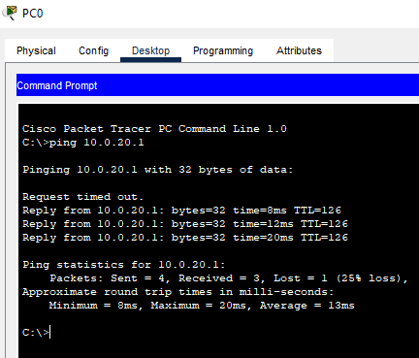

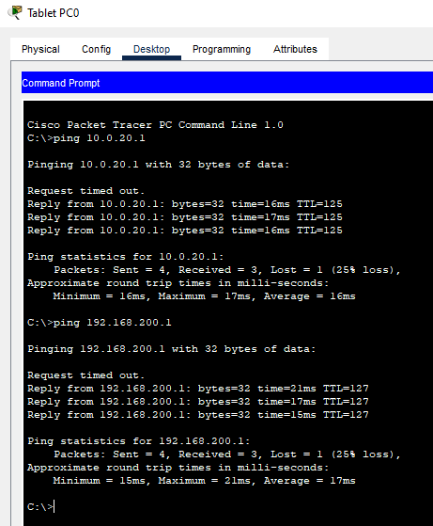

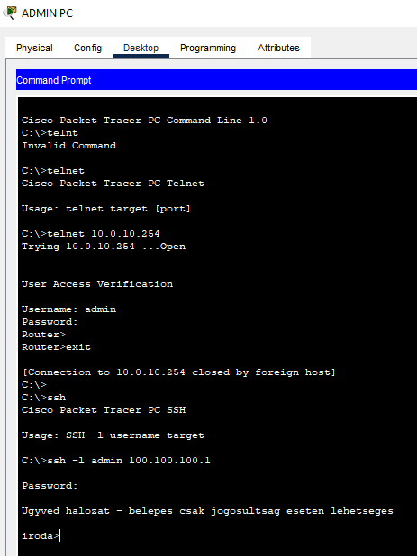

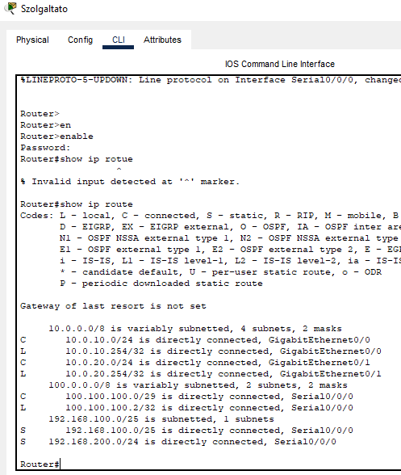

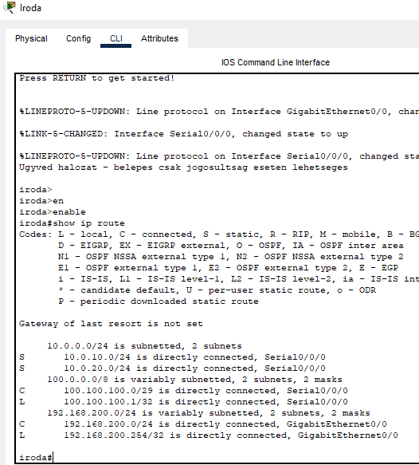 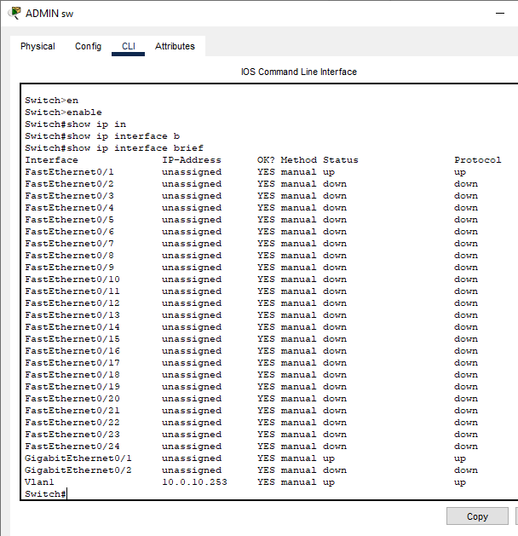

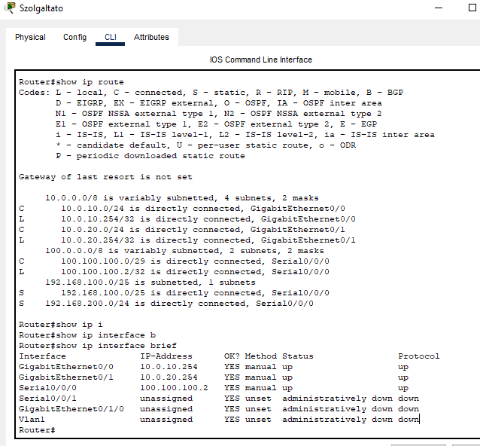



10.

Szolgaltato#show running-config

Building configuration...

Current configuration : 1336 bytes

!

version 15.1

no service timestamps log datetime msec

no service timestamps debug datetime msec

no service password-encryption

!

hostname Szolgaltato

!

!

!

enable password ugyved

!

!

ip dhcp excluded-address 10.0.10.0 10.0.10.10

ip dhcp excluded-address 10.0.10.243 10.0.10.253

!

ip dhcp pool FELSO

network 10.0.10.0 255.255.255.0

default-router 10.0.10.254

dns-server 8.8.8.8

!

!

!

no ip cef

no ipv6 cef

!

!

!

username admin password 0 admin

!

!

license udi pid CISCO1941/K9 sn FTX1524GV5S-

!

!

!

!

!

!

!

!

!

!

!

spanning-tree mode pvst

!

!

!

!

!

!

interface GigabitEthernet0/0

description IRODA irananyaba

ip address 10.0.10.254 255.255.255.0

duplex auto

speed auto

!

interface GigabitEthernet0/1

description IRODA irananyaba

ip address 10.0.20.254 255.255.255.0

duplex auto

speed auto

!

interface Serial0/0/0

ip address 100.100.100.2 255.255.255.248

clock rate 2000000

!

interface Serial0/0/1

no ip address

clock rate 2000000

shutdown

!

interface GigabitEthernet0/1/0

no ip address

shutdown

!

interface Vlan1

no ip address

shutdown

!

ip classless

ip route 192.168.200.0 255.255.255.0 Serial0/0/0

ip route 192.168.100.0 255.255.255.128 Serial0/0/0

!

ip flow-export version 9

!

!

!

!

!

!

!

line con 0

!

line aux 0

!

line vty 0 4

password admin

login local

line vty 5 15

password admin

login local

!

!

!

end

Szolgaltato#